**Question 1: Created a new excel file and write the data’s into the excel file through java program**

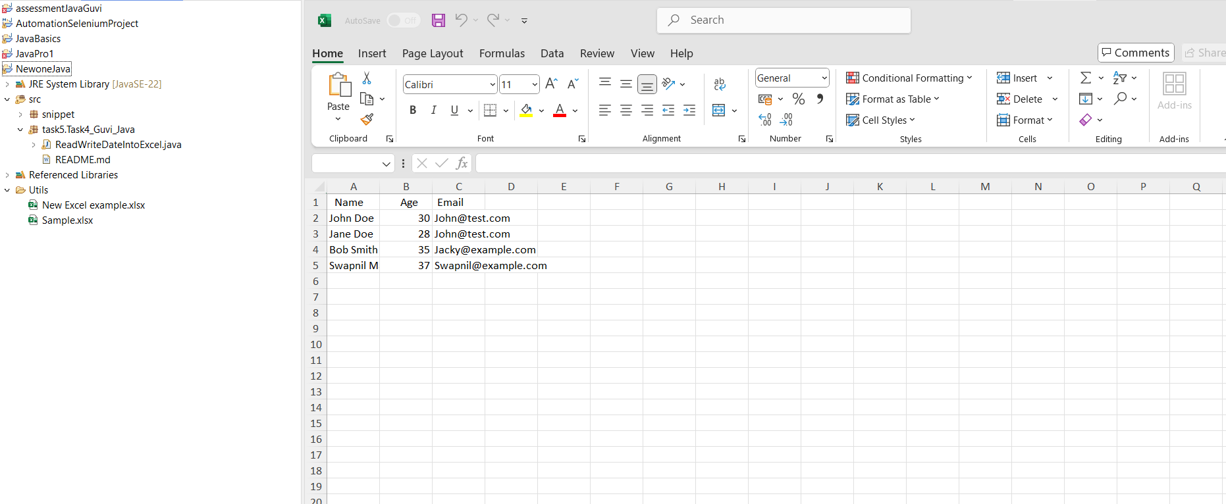

**Read that data from created excel file:**

